

**Instituto Politecnico Nacional**

**ESCOM “Escuela Superior de Cómputo”**

INGENIERÍA SISTEMAS COMPUTACIONALES

*Analisis Fundamental de Circuitos*

*Práctica 7: Operaciones aritméticas*

PROFE: Fernando Aguilar Sánchez

ALUMMNO: Rojas Alvarado Luis Enrique

GRUPO: 2CM2

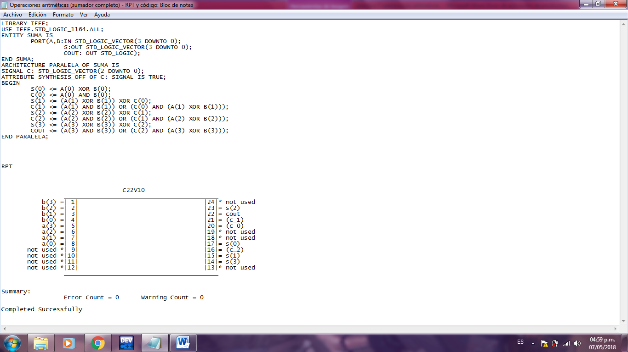**CÓDIGO VHDL Y RPT**

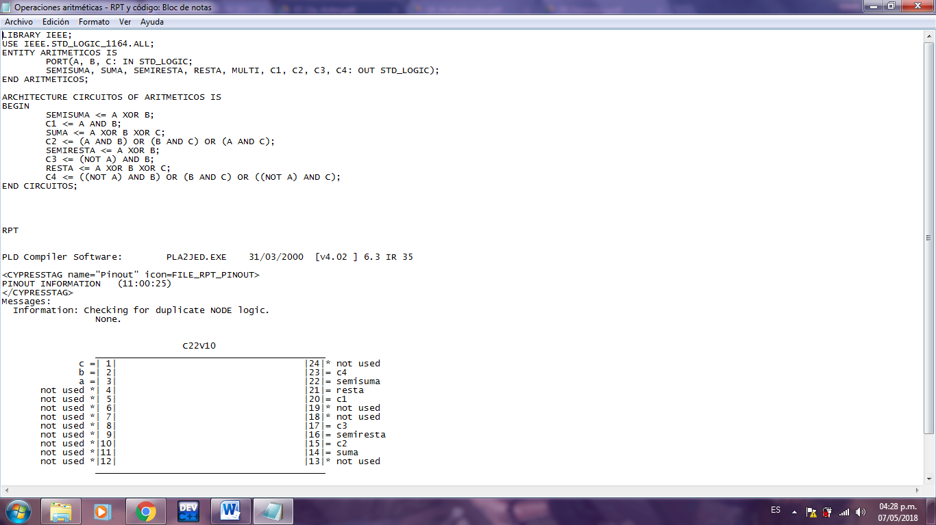

**TABLAS DE VERDAD**

* **Medio sumador**

|  |  |  |  |  |
| --- | --- | --- | --- | --- |
| # | A | B | ∑ | CARRY |
| 0 | **0** | **0** | **0** | **0** |
| 1 | **0** | **1** | **1** | **0** |
| 2 | **1** | **0** | **1** | **0** |
| 3 | **1** | **1** | **0** | **1** |

* **Sumador Completo**

|  |  |  |  |  |  |
| --- | --- | --- | --- | --- | --- |
| # | A | B | Cin | ∑ | Cout |
| 0 | **0** | **0** | **0** | **0** | **0** |
| 1 | **0** | **0** | **1** | **1** | **0** |
| 2 | **0** | **1** | **0** | **1** | **0** |
| 3 | **0** | **1** | **1** | **0** | **1** |
| 4 | **1** | **0** | **0** | **1** | **0** |
| 5 | **1** | **0** | **1** | **0** | **1** |
| 6 | **1** | **1** | **0** | **0** | **1** |
| 7 | **1** | **1** | **1** | **1** | **1** |

* **Medio Restador**

|  |  |  |  |  |
| --- | --- | --- | --- | --- |
| # | A | B | R | B |
| 0 | **0** | **0** | **0** | **0** |
| 1 | **0** | **1** | **1** | **1** |
| 2 | **1** | **0** | **1** | **0** |
| 3 | **1** | **1** | **0** | **0** |

* **Restador Completo**

|  |  |  |  |  |  |
| --- | --- | --- | --- | --- | --- |
| # | A | B | Bin | Z | Bout |
| 0 | **0** | **0** | **0** | **0** | **0** |
| 1 | **0** | **0** | **1** | **1** | **1** |
| 2 | **0** | **1** | **0** | **1** | **1** |
| 3 | **0** | **1** | **1** | **0** | **1** |
| 4 | **1** | **0** | **0** | **1** | **0** |
| 5 | **1** | **0** | **1** | **0** | **0** |
| 6 | **1** | **1** | **0** | **0** | **0** |
| 7 | **1** | **1** | **1** | **1** | **1** |

* **Sumador Completo de 4 bits**

Se unen 4 sumadores completos de 1 bit

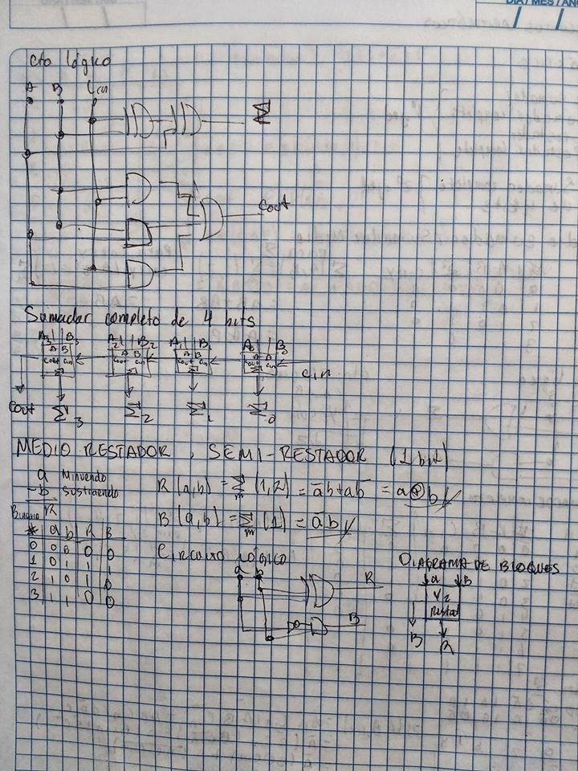

|  |  |  |  |  |  |  |  |  |  |  |  |  |  |  |
| --- | --- | --- | --- | --- | --- | --- | --- | --- | --- | --- | --- | --- | --- | --- |
| **#** | **Cin** | **A3** | **A2** | **A1** | **A0** | **B3** | **B2** | **B1** | **B0** | **Cout** | **Σ3** | **Σ2** | **Σ1** | **Σ0** |
| **0** | 0 | 0 | 0 | 0 | 0 | 0 | 0 | 0 | 0 | 0 | 0 | 0 | 0 | 0 |
| **1** | 0 | 0 | 0 | 0 | 1 | 0 | 0 | 0 | 1 | 0 | 0 | 0 | 1 | 0 |
| **2** | 0 | 0 | 0 | 1 | 0 | 0 | 0 | 1 | 0 | 0 | 0 | 1 | 0 | 0 |
| **3** | 0 | 0 | 0 | 0 | 1 | 0 | 0 | 0 | 0 | 0 | 0 | 0 | 0 | 1 |
| **4** | 0 | 1 | 0 | 0 | 1 | 0 | 1 | 0 | 0 | 0 | 1 | 1 | 0 | 1 |
| **5** | 0 | 0 | 1 | 1 | 1 | 1 | 0 | 0 | 0 | 0 | 1 | 1 | 1 | 1 |
| **6** | 0 | 1 | 0 | 0 | 0 | 1 | 0 | 0 | 0 | 1 | 0 | 0 | 0 | 0 |
| **7** | 0 | 1 | 1 | 1 | 0 | 1 | 0 | 0 | 0 | 1 | 0 | 1 | 1 | 0 |
| **8** | 0 | 1 | 1 | 0 | 0 | 0 | 0 | 1 | 0 | 0 | 1 | 1 | 1 | 0 |
| **9** | 0 | 0 | 1 | 0 | 0 | 0 | 1 | 1 | 1 | 0 | 1 | 0 | 1 | 1 |
| **10** | 0 | 0 | 0 | 1 | 0 | 1 | 0 | 0 | 0 | 0 | 1 | 0 | 1 | 0 |

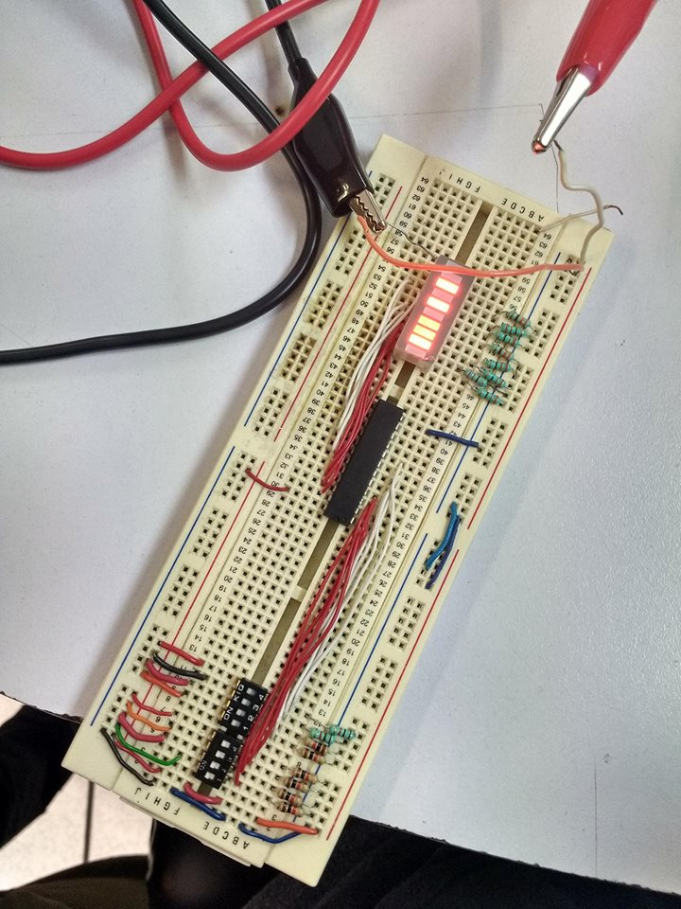**FOTOS**

